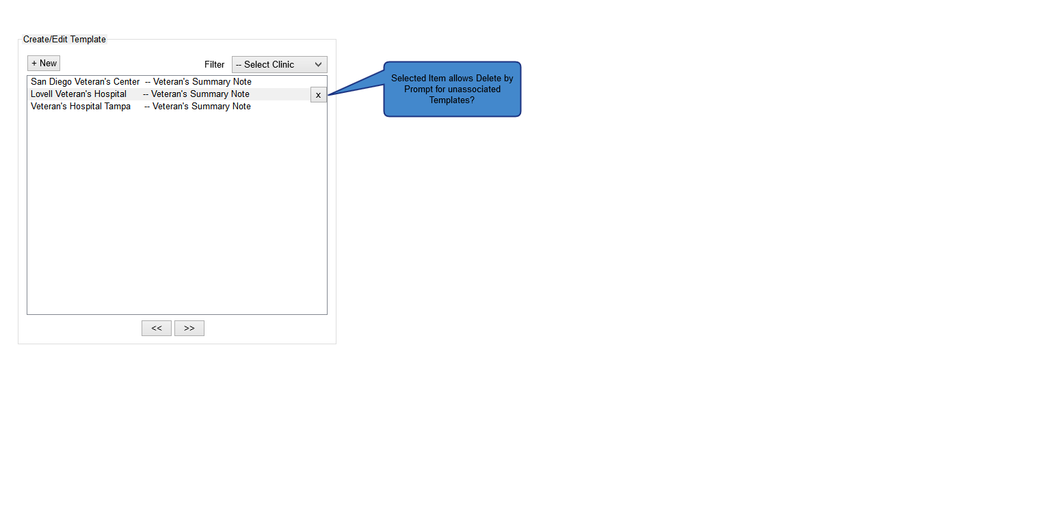

Figure 1: Template List View

* On initial navigation, the user is presented with this view – a listing of defined Templates, filterable by type. Paging controls will be provided for long lists, and for unassociated Templates, the ability to Delete via inline button click (with prompt).
* The user can select the an existing Template for editing, or add a new Template. Selection of either takes the user to the Template Editor view.

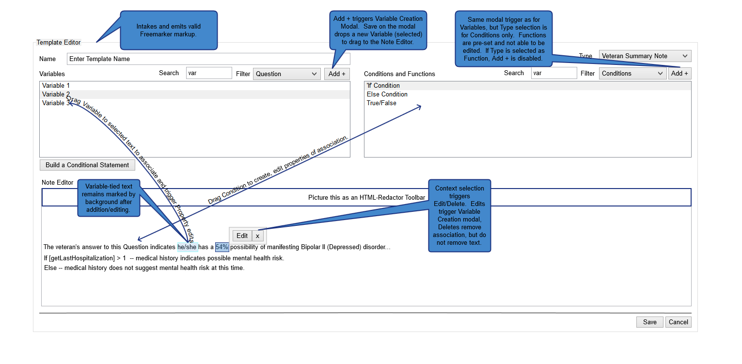

Figure 2: Template Editor View

* In this view, the user can create or edit a Template, by defining text, creating associations, building inline Conditional statements, and mapping variables to text elements.
* The user can toggle between an HTML redactor text editor view, and a preview of the Template as it is being defined. Conditional statements are stored as Variables, and the user can create a new Conditional statement on directly from the Template Editor. Associates in inline text can be edited via selection, or deleted, without altering the base text in the Template. Filters and paging are provided for long lists, both for Conditional statements and defined Variables.
* When the user chooses to define or edit a Conditional statement, the user is taken to the Statement Editor view.

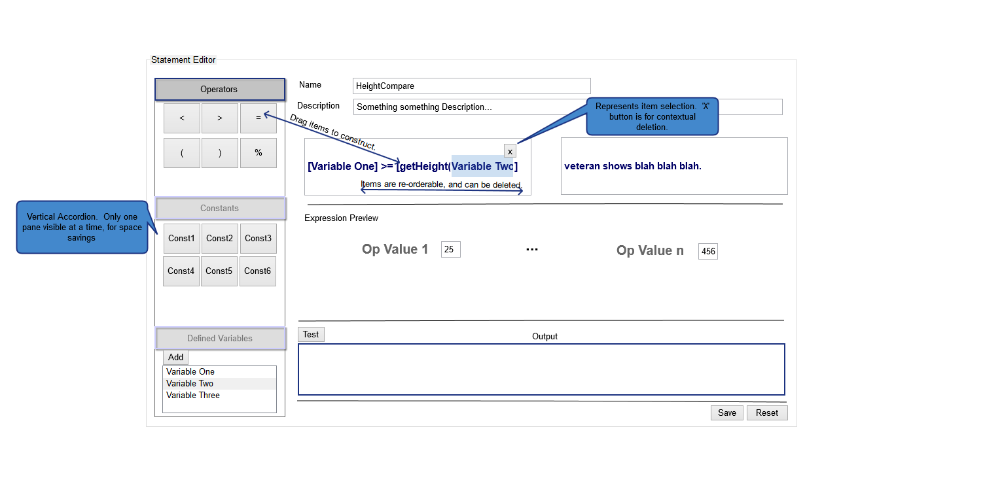

Figure 3: Statement Editor View

* In this view, the user can define or edit a Conditional statement, by constructing the statement from conditional operators (greater-than, less-than, equivalence, AND, OR, etc.), as well as edit the text that will be viewable when conditions for that statement are met. There is a preview/test feature that will allow the user to dummy values and test output, and the statement build is performed by drag and drop. Inline statement elements can be deleted in context, by selection, and the elements in the statement can be reordered. Where defined Variables (Formulas, etc.) are in an editable state, they can be edited by triggering a modal view, and Variables can be added via modal without removing the user from the Statement Editor context.